Architecture

Team ID: [SWTID-2026-9714]
Team Members :
- S Bhuvaneswari – bhuvaneswari2007b@gmail.com
- A Gayathri – gayug6904@gmail.com
- P Vaishnavi – vaishnavipandi0702@gmail.com
- B Maha – mahasuila8778@gamil.com
- R Rangeela – rangeela6122006@gmail.com

Department/Institute: [Computer Science Department] | Date: [8/3/2026]

This document presents the complete solution architecture for a secure, JWT-based product inventory management system built on the MERN stack. The following sections provide a comprehensive technical overview for evaluation and implementation.

01

Executive Summary
Project overview and key objectives
02

Architecture Goals
Design principles and success criteria

03

High-Level Architecture
System components and data flow

04

Component View
Technical stack and responsibilities

05

Data Model
Schema design and relationships

06

API Design
Endpoints and request/response patterns

07

Quality Attributes
Non-functional requirements

08

Development Phases
Implementation roadmap

09

Risks & Mitigations
Technical challenges and solutions

10

Conclusion
Architecture summary and readiness



Executive Summary
This project implements a secure, scalable backend for product inventory management using Node.js, Express.js, MongoDB, and JWT-based authorization. The API exposes two primary domains: authentication endpoints for user registration and login, and product management endpoints supporting full CRUD operations with user-scoped access control.
The architecture prioritizes data privacy through token-based authentication, where each product operation is automatically filtered by the authenticated user's ID. This ensures users can only access their own inventory data while maintaining clean separation between authentication and business logic domains. The system follows REST conventions with consistent error handling, structured middleware, and fast response times suitable for real-time inventory tracking applications.

Architecture Goals



Technical Solution
Identify optimal stack: Node.js + Express for efficient APIs, MongoDB for flexible document storage, JWT for stateless authentication

System Structure
Define modular MVC/layered architecture ensuring scalability and maintainability through clear separation of concerns

Feature Roadmap
Outline phased delivery: backend setup → auth APIs → product CRUD → testing and optimization

Quality Standards
Establish specifications for REST conventions, token-based authorization, structured middleware, and performance

- High-Level Architecture

System Overview

Transport
HTTPS REST with Axios
API & Data
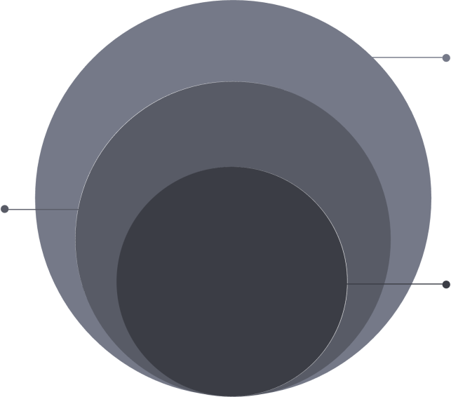
Express routes, controllers, middleware; MongoDB users & products

Client
React / Vite frontend

Component View
The architecture decomposes into six key components, each with clearly defined responsibilities and technology choices.

Component | Responsibility | Technologies
API Gateway / Express App | HTTP server, route mounting, JSON parsing, CORS configuration | Express.js, cors
Auth Service | User registration/login, password hashing, JWT issuance and verification | bcryptjs, jsonwebtoken
Product Service | Product CRUD operations with search; enforces user ID isolation | Express controllers + Mongoose
Middleware Layer | Token verification, input validation, error handling, request logging | Custom middleware
Data Access (ODM) | Schema definition, document validation, query building, index management | Mongoose
Database | Persistent document storage with efficient querying | MongoDB (Atlas/local)

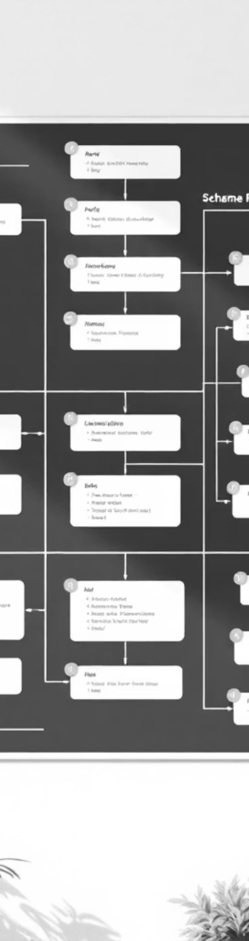

Data Model

Schema Design

User Collection
Fields: name (String, required), email (String, unique, lowercase, required), password (hashed with min length policy), timestamps
Indexes: { email: 1 } for fast lookups
Product Collection
Fields: name (String, required), price (Number ≥ 0), quantity (Number ≥ 0, default 0), description (String),
userId (ObjectId → User, required), timestamps
Indexes: { userId: 1, createdAt: -1 }, { userId: 1, name: 1 }

Relationship

User (1) — (M) Product: One-to-many relationship established through userId reference field in products, enforcing ownership and access control at the data layer.

API Design Summary

Base URL: http://localhost:/api/v1
1
2
3

POST /auth/register

Request: { name, email, password }
Response: { message, token, user: { id, name, email } }

Creates account with hashed password

POST /auth/login
Request: { email, password }

Response: { message, token, user: { id, name, email } }

Verifies credentials and returns JWT

POST /products
Request: { name, price,
quantity, description }
Response: { success, message, product }
Creates product owned by authenticated user

4
5
6

GET /products
Query:
?keyword=&page=&limit=
Response: { success, products, pagination }
Search with pagination, newest first

GET /products/:id
Response: { success, product
}
Fetch single product with ownership check

PUT /products/:id
Request: Partial fields
Response: { success, message, product }
Updates provided fields only



7

DELETE /products/:id
Response: { success, message } Deletes product if owned by requester

Authentication: All product endpoints require Authorization: Bearer <JWT> header. Missing or
invalid tokens return 401 Unauthorized.

Quality Attributes & Development Specifications

Security
JWT with minimal claims, bcrypt password hashing, protected routes, secrets in environment variables only

Performance
Pagination on list endpoints, MongoDB
indexes, responses ≤2s under normal load


Reliability
Fail-fast DB connection, standardized error shape { success: false, message, code }

Maintainability
Modular controllers, linting/prettier, small focused functions, consistent logging


Scalability
Stateless API enables horizontal scaling behind reverse proxy, MongoDB Atlas for clusters

Development Specifications

Availability
Graceful server start/stop, minimal downtime during deployments

- REST standards: nouns for resources, plural paths, proper status codes, idempotent PUT/DELETE
- Validation: required fields, type checks, numeric ranges with 400 responses
- Error format: never leak stack traces to clients in production
- Data minimization: never return password, keep JWT payload small
- Pagination defaults: page=1, limit=10 (configurable)
- Code health: ESLint + Prettier, meaningful logs, .env.example included

- Development Phases, Risks & Conclusion

Development Phases & Deliverables

Phase 1: Foundation
Project setup, MongoDB connection, User schema with bcrypt hashing, server boot with environment validation

Phase 2: Authentication
Auth APIs (register/login), JWT middleware implementation, Postman smoke tests for token flow

Phase 3: Product Features
Product CRUD operations, user isolation logic, MongoDB indexes, search with pagination

Phase 4: Polish
Error handling standardization, input validation, performance tuning, documentation completion



Risks & Mitigations

Risk | Mitigation
Missing environment variables | Startup validation with explicit error messages
Malformed/expired tokens | Robust middleware with friendly 401/403 responses
Duplicate email race condition | Unique index enforcement with conflict handling
Unbounded queries | Pagination limits, controller guardrails
Version mismatches | Pin versions in package.json, local verification
Conclusion
This architecture successfully meets all stated goals: secure JWT authentication with bcrypt password hashing, user- scoped product operations with automatic ownership filtering, clean modular structure with clear separation between authentication and business domains, and performance-ready data access through strategic indexing. The system is positioned for seamless frontend integration with React/Vite and provides a solid foundation for future enhancements including advanced analytics, reporting dashboards, and integration with external inventory systems.

